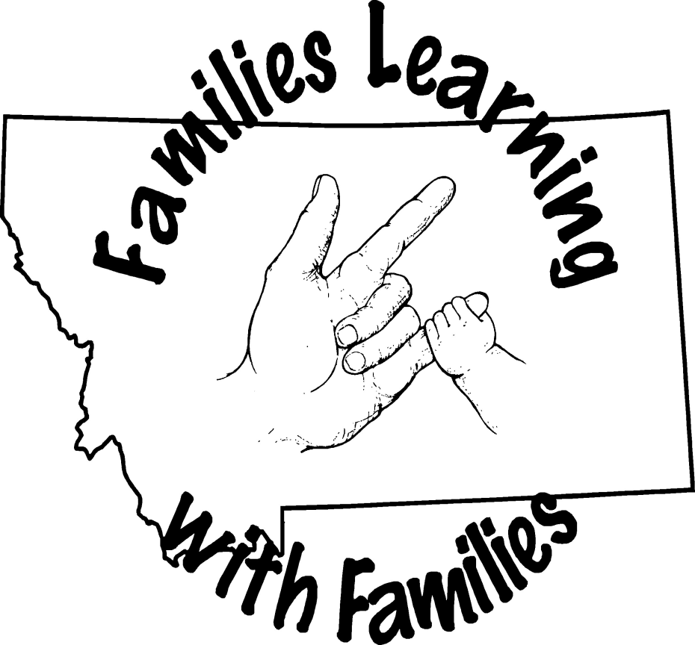
28th Annual
FAMILY LEARNING WEEKEND for
FAMILIES OF Deaf and Hard of Hearing Children
June 7-9, 2024

What: MSDB 28th Annual Family Learning Weekend for the Deaf and Hard of Hearing
Where: MSDB Campus in Great Falls
When: June 7-9, 2024
Who: Families of Deaf and Hard of Hearing Children living in Montana!
Why: IT WILL BE FUN!!

The Learning Weekend is a creative program providing opportunities for families of sensory impaired children to learn about deafness, share their experiences with other families, and learn how to communicate more fully with one another in a warm, caring atmosphere.

The focus of the weekend is to enhance each individual’s personal knowledge of deafness and how it relates to the education and development of their child. Informal workshops, group discussions (parent groups, kids’ groups, siblings’ groups, etc.) and hands-on activities will be offered. Child care and recreation for the children (siblings included) is available at no charge. Families will be reimbursed for mileage at the current state rate.

Housing is provided on a first-come first-serve basis. Each family is generally provided with their own suite of rooms in the cottages and efforts are made to make assignments according to individual needs and preferences. Typically each family has their own bathroom, sometimes two, depending on the size of the family. Participants need to bring personal items such as soap, shampoo and toothpaste. The MSDB Swimming Pool is OPEN!!!! Please bring your swimming suit. There will be time for the kids to swim and family swim later on Saturday.

Children’s Programs:
The children are divided into groups based mostly on age. Many factors are taken into consideration including friendships, maturity level, and interests when putting together the groups. The children stay with their groups until they join the parents for mealtime. MSDB’s finest residential and school staff will be responsible for supervising your children and making sure they enjoy the day as much as you do!

Birth to two: Children will be Camas wing with staff with staff to provide supervision. Parents should pick up their children prior to lunch and dinner and return them to the same location when they are done eating.
Three to five: Children will be involved in a variety of activities throughout the day. These activities will include snacks, program practice, indoor and outdoor activities including a trip to the MSDB playground (weather permitting). The activities for this group will remain flexible depending on the ages and abilities of the participants.

Six through eighteen: Saturday morning after the group picture, children will re-join their assigned teams which are designed for children to be involved with peers. There will be several activities including program practice, recreation activities and snacks. In addition, a representative from the Montana Telecommunications Access Program (MTAP) will have fun projects for the children to enjoy. MTAP will talk about technology, including using a VP, the Video Relay Service, etc. Also during the morning session MSDB Counselors will meet with hearing siblings providing them an opportunity to discuss their feelings regarding having a deaf sibling. Deaf and Hard of Hearing children will meet separately to share their thoughts as well. This information (while names confidential) will be shared with the parents during the Sunday morning presentation.

***The kids program is intended to provide entertainment and educational activities that will further the participants understanding of deafness and its impact on the family. Activities are designed for youth with hearing loss and for their siblings. Participants are grouped by age and staff are assigned accordingly, depending on the numbers of the participants and their individual needs. If you have unique concerns regarding your child, please let us know and we will work with you to insure that everyone has a good time.
Information from various vendors (serving Deaf and Hard of Hearing) will be available throughout the weekend.

Presenter Bios
John Fechter, Regional Outreach Manager – Hamilton Relay As a volunteer for more than twenty-five years, John currently serves as board member for Metro Deaf School and Minnesota Council on Disabilities. In addition, John is very actively involved with Deaf Equity, a local nonprofit organization, focusing on volunteerism, civic engagement and training for deaf and hard of hearing community in Minnesota. At Hamilton Relay, John is responsible for directing outreach personnel and managing activities to ensure that all state outreach is carried out according to specific objectives. He works with outreach staff to ensure effective communication with relay users on new development and service enhancements in each of their states. A graduate of Gallaudet University, John resides near Minneapolis, MN and has two children who are both deaf. They are currently students at Gallaudet University, majoring in Social Work (Masters) and Elementary Education (Undergraduate). John has been to all 50 states and enjoys traveling.
John Fechter IV “J4” is a graduate of Gallaudet University with a Bachelor’s Degree in Elementary
Education. He is a third grade teacher who also coaches basketball and volleyball.
Gary McManus, was an MSDB Teacher/Coach for 40 years. He also attended MSDB when he was a student. He is truly honored by being named Teacher of the Year (twice!), coach of the year as well as being inducted into three Hall of Frames (HOF): Northwest Athletic Association of the Deaf Hall of Fame as a player/coach (covering 7 states and Canada); Montana School for the Deaf and the Blind Hall of Fame and the Special Olympics Hall of Fame. Gary says his joy was working with students to make a difference in their lives. Gary also serves on the MSDB Foundation Board of Directors.
Pamela Snedigar, as Director of the Gallaudet University Regional Center – West (located at Ohlone College in Fremont, CA) since 1999; Pam provides systems analysis related to deaf education. Including design, implementation and support of specialized projects serving regional needs. She holds Bachelors of Science in Criminal Justice Administration, a Paralegal Certificate, and a Master’s in Public Administration from California State University Hayward. She has further studies in Community College Administration from Alliant International University. She was a paralegal at the California Center for Law and the Deaf (CalCLAD) for 10 years; in that capacity she provided direct services, legislative review, advocacy training and community education. Her interests and current position have led her to develop many training and continuing education opportunities for professionals and families, as well as workshops for deaf and hard of hearing students. Along with providing opportunities for interpreter language development in math and sciences, she has developed training on cultural issues for deaf and hearing interpreters who have deaf parents, leadership (with an emphasis on women of color), advocacy, ethics. Workshops for students include financial literacy for K-12 students, and college/career readiness. Her personal motto is in memory of her deaf parents, “everyone deserves the opportunity to develop language and by using language we develop an educated populace”.
GURC-West Description (MSDB FLW Sponsor) The GURCs were established in 1977. Through partnerships with host institutions, the four GURC share Gallaudet’s undergraduate and graduate programs and the Laurent Clerc National Deaf Education Center’s resources and expertise through training programs, workshops and conferences, youth programs, technical assistance, and consultation with deaf and hard of hearing individuals and their communities. Ohlone College in Fremont, California is the seat of Gallaudet University Regional Center – West. GURC-West serves the western portion of the United States and its territories.
GURC-West has been a proud sponsor of the Montana Family Learning Weekend since 2004.
Sherri Widhalm, MS, CCC-SLP, LSLS Cert. AVEd.:
Sherri R. Widhalm, MS, CCC-SLP, LSLS Cert. AVEd, is a speech language pathologist and family adviser at the Montana School for Deaf and Blind. She also maintains a private practice, Sound Start Therapy of Montana, specializing in the development of speech, language, and listening in both children and adults who are deaf or hard-of-hearing. Sherri has received board certification in Listening and Spoken Language (LSLS AVEd), which supports children with hearing loss in the development of the auditory cortex of the brain in order to listen and understand spoken language. Her focus is early identification of hearing loss in children, intervention with appropriate hearing technology, and the use of auditory verbal strategies to develop speech, language, and listening skills comparable to typically hearing peers. She provides guidance and support to families of children with hearing loss at the Montana School for Deaf and Blind and across the state of Montana. Other certifications include the Clinical Certificate of Competence from the American Speech-Language-Hearing Association and the Lee Silverman Voice Treatment (LSVT). Mrs. Widhalm has received multiple ACE awards (Award for Continuing Education) from the American Speech-Language- Hearing-Association, which recognize professionals who have demonstrated lifelong learning.

Deaf Learning Weekend 2024 Schedule
(subject to change)
Friday, June 7, 2024
4:00-6:00 | Check in: Yellowstone Cottage. Room Assignments and Family Picture
5:00 | Tour: Especially helpful for first time attendees. Meet in the Yellowstone Lobby.
5:30-6:20 | Dinner: Pizza, salad and dessert in the MSDB main dining room.
6:30-6:50  7:00-7:05  7:05-7:55 | Welcome: Parents and children in the Mustang Center (Gym).  All children (except the White Team) will remain in the Mustang Center. Parents will go to Bitterroot.  Introduction: (IMC)  Gary McManus: see Gary’s bio his presentation will be thought provoking and humorous.
8:00-8:45 | Young Adult Panel: Pre-selected individuals will share their journey. This is a very powerful session for the audience as well as the panel members!
8:45 | Pick up your kids from the Mustang Center.
Saturday, June 8, 2024
7:45-8:45 | Breakfast in the main dining room.
8:45-9:00 | Group Picture – All Participants together in front of the big sign (each family will get a “Memory Book” at the end of the weekend to take home).
9:00-10:30 | Pam Snedigar - "Stories of a Lifetime” see Pam’s bio for more information about her experiences
10-30-1045  10:45-11:30  11:30- 11:45  11:45:-12:45  12:00-12:45 | Break  Assistive Technology Workshop – How to wake up, smoke alarms, baby monitors, etc.  TBA  Pick up your children, they’re yours for lunch  Lunch in the Dining Room
12:45-1:05 | Kid’s Program - Mustang Center (Gym)
1:15-2:15  2:15-3:15 | Choice 1 – Unilateral Loss  Choice 2 – Listen and Spoken Language  Choice 3 – American Sign Language  Choice 1 – American Sign Language  Choice 2 - TBA  Choice 3 - TBA
3:15-3:30  3:30-4:30 | Break  Parent Groups  - Mom’s Group - Conference Room in the Basement  - Dad’s Group – Life Skills Room  - Grandparent (other caregiver) Group - (if enough interested)- Outreach Office
4:45-5:45  6:00-7:00 | OPEN SWIM FOR FAMILIES Free Time  BBQ: Dinner in the main dining room
7:00-7:15  7:15-8:00  8:00-8:55 | MSDB’s Role  Special Presentation  Parent Panel – This is always a very popular session for both the presenters and the participants in the audience - IMC  Children will be in the cottages watching movies with their group or playing outside.
9:00 | Pick up your kids from the cottages
Sunday, June 9, 2024
7:45-845 | Breakfast in main the Dining Room
9:00-10:30 | MTAP presenters
10:30-11:00  11:00-11:30  11:30-12:15  12:15 | Sibling Summary – MSDB Student Life Counselors will share with you information from the siblings of your DHH child. This session is intended to be “light and informing”.  Evaluations, “Memory Book” and/or “Photo” and closing  Pick up Children – Lunch  Everyone should be on their way! Have a wonderful summer and travel safe!
28th Annual
FAMILY LEARNING WEEKEND for
FAMILIES OF Deaf and Hard of Hearing Children
June 7-9, 2024

WHAT OTHERS HAVE SAID ABOUT MSDB’s FAMILY LEARNING WEEEKENDS!

"I think every family with a deaf child should come to at least one to see if it’s helpful to them – we love it and learn each and every time we come to MSDB!”

"I like that my brother feels welcome and fits in every time he is here and I support him."

"I was very impressed with MSDB in general. I had no idea that this was such a 'gem'. Montana is very lucky."

"Informative, we met a lot of amazing families, the staff was great and the kids had fun”

"Seeing all the kids together is the best part! We always learn something new that helps us with our lives!"

"The staff are great, always different options for presenters – changes every year”

SPONSORED BY:
The Montana School for the Deaf and the Blind The M.S.D.B. Foundation, Inc.
Gallaudet University Regional Center – West at Ohlone College The Montana Office of Public Instruction

Joel Barish is an adventurer who has visited 103+ nations around the world in an effort to live as much
of the Deaf experience as possible. Joel has discovered Deaf individuals in every corner and has shared
thousands of unique stories with others with sign language videos and social media. As the co-founder of DeafNation, Joel uses his platform to host two popular programs that are distributed widely via social media channels. The first, the acclaimed No Barriers with Joel Barish is an inspiring, adventurous travelogue in Sign
Language that allows viewers to join Joel as he tastes unique cuisine, meets inspirational Deaf business
owners, and explains the significance of various landmarks he travels to. Notable episodes include going
6,500 feet under the earth to mine gold with a Deaf South African gold miner and hunting for survival
while boating with Deaf native Inuit in Greenland.
Joel is invested in supporting local Deaf communities in his travels and videos, working with local
tourism offices to help increase awareness and accessibility for traveling Deaf individuals. In his travels,
videos, and interactions with others, Joel emphasizes patronage of Deaf-owned businesses as well as
businesses that are accessible for traveling Deaf individuals. The No Barriers with Joel Barish audience is
highly engaged, and many follow in his footsteps, taking similar travel itineraries as seen in the show.
Hundreds of shows have created a wonderful avenue for the signing community to learn about native
Deaf communities in other places. Coffee With Joel Barish is a talk show distributed on social media where Joel interviews notable Deaf people on a variety of topics. Joel’s guests include leaders, politicians, and individuals with interesting professions or experiences and covers topics that are interesting and relevant to the Deaf and signing community.

